

ASSIGNMENT REPORT

|  |  |  |
| --- | --- | --- |
| COURSE CODE | : | BTPR2053 |
| COURSE | : | Fundamental Of Image Processing |
| SEMESTER & YEAR | : | Semester 1 2020 |
| INSTRUCTOR | : | Pang Yee Yong |

|  |  |  |
| --- | --- | --- |
| Nama | Student ID | Batch |
| Lam Wei Chun | B180279C | BoSE18-C2 |

**Assignment 1**

Input: yoda.tif

Output:

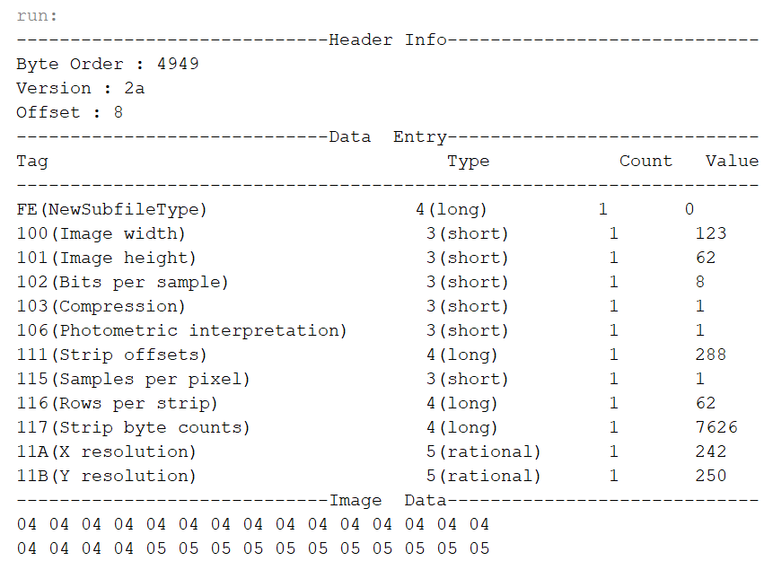

**Assignment 2**

Input:

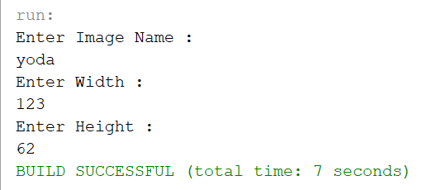

Output:

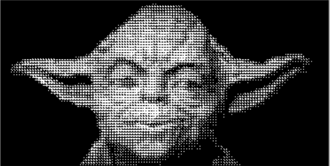



Yoda.raw (Original Image) yoda_pattern.raw

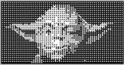 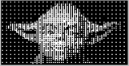

yoda_D1.raw (2X2) yoda_D2.raw (4X4)

**Assignment 3**

Input:

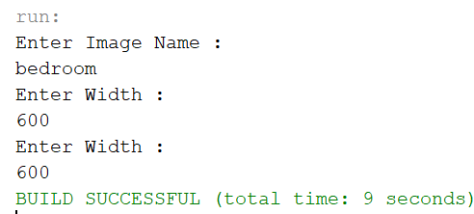

Output:

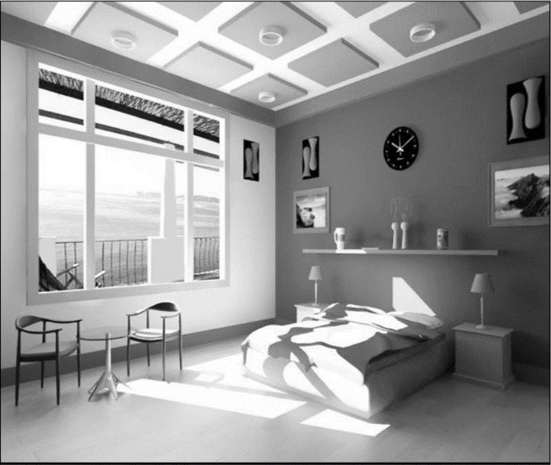

Bedroom.raw (Original Image)

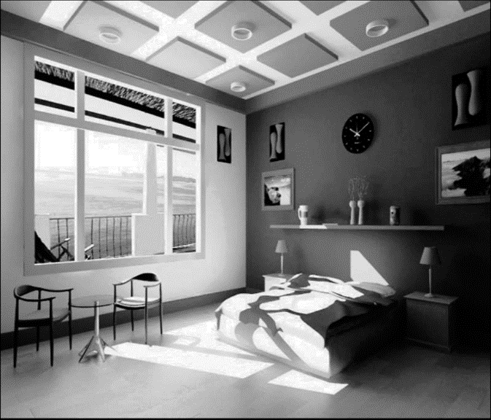

Bedroom_his.raw

**Assignment 4**

Input:



Output:



Bedroom.raw (Original Image)

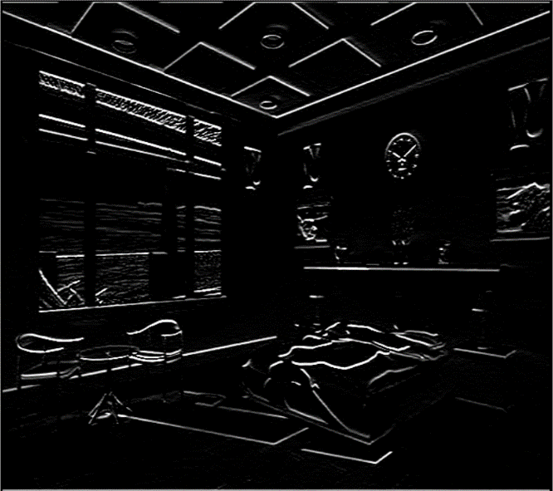

bedroom_convolution.raw

**Assignment 5**

Input:



Output:



Bedroom.raw (Original Image)

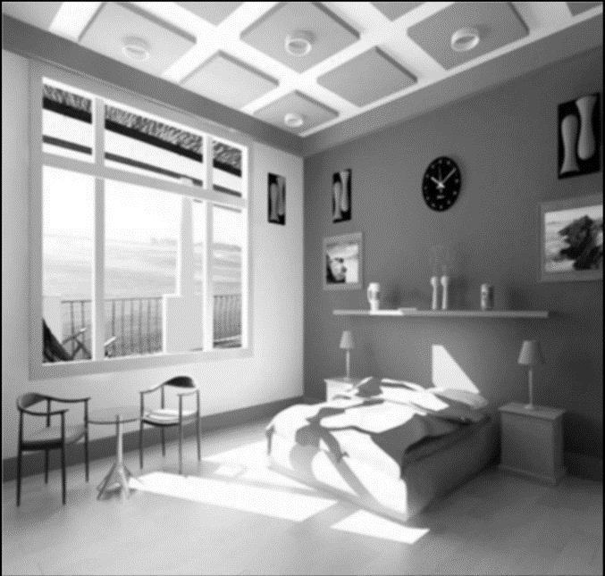 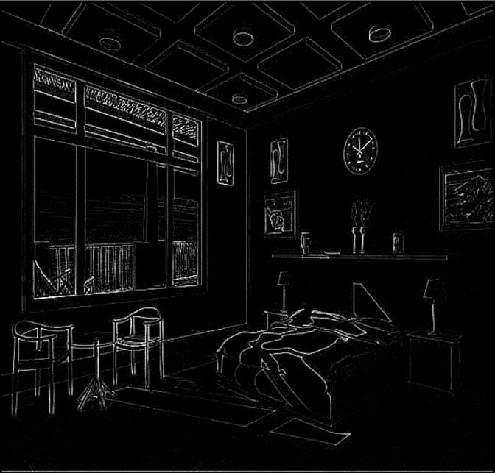

Bedroom_low.raw (Low Pass Filter) Bedroom_high.raw (High Pass Filter)